Lab Setup Week 1 Project ( Kali linux machine on Virtual BOX )
PHASE 1
Step 1. Download & install 7-zip: https://7-zip.org/download.html
I have already the winrar so I skipped this isntalllation of 7 zip
Step 2. Download & install Virtualbox on your laptop/PC: https://virtualbox.org/wiki/Downloads
I have already downloaded the VirtualBox (version 7.2.16)
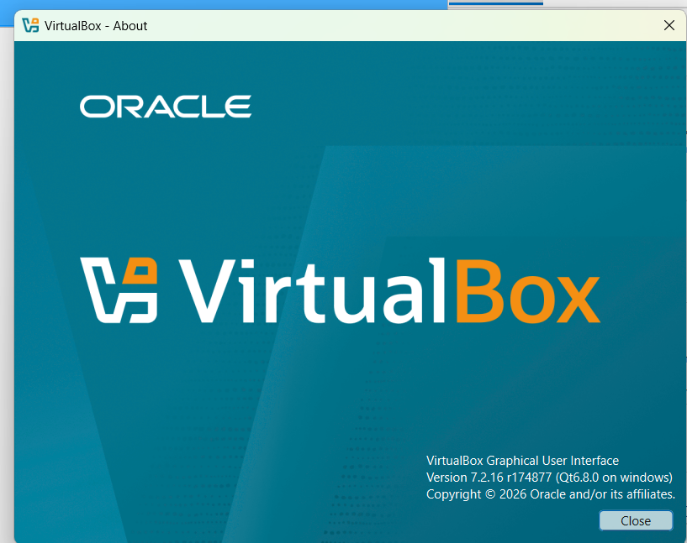

Step 3. Configure the network settings on your Virtualbox (create NATNetwork in 10.0.0.0/24)
Go to File -> Tools -> Network
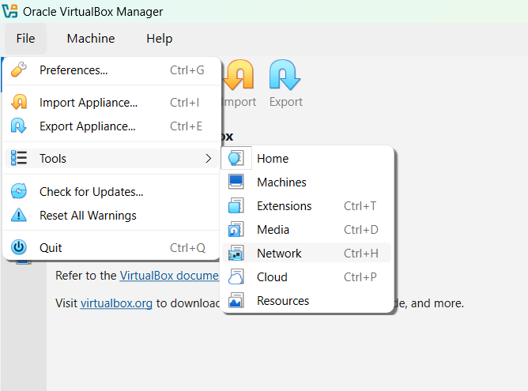
Go to Nat Networks
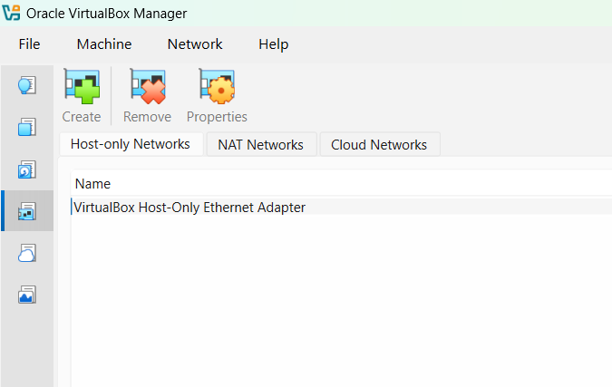

Click on Create
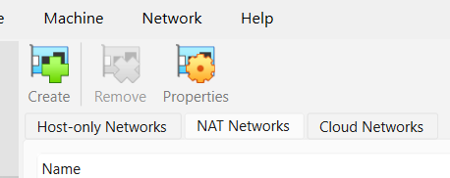
New name (NatNetwork) appears Click on Apply
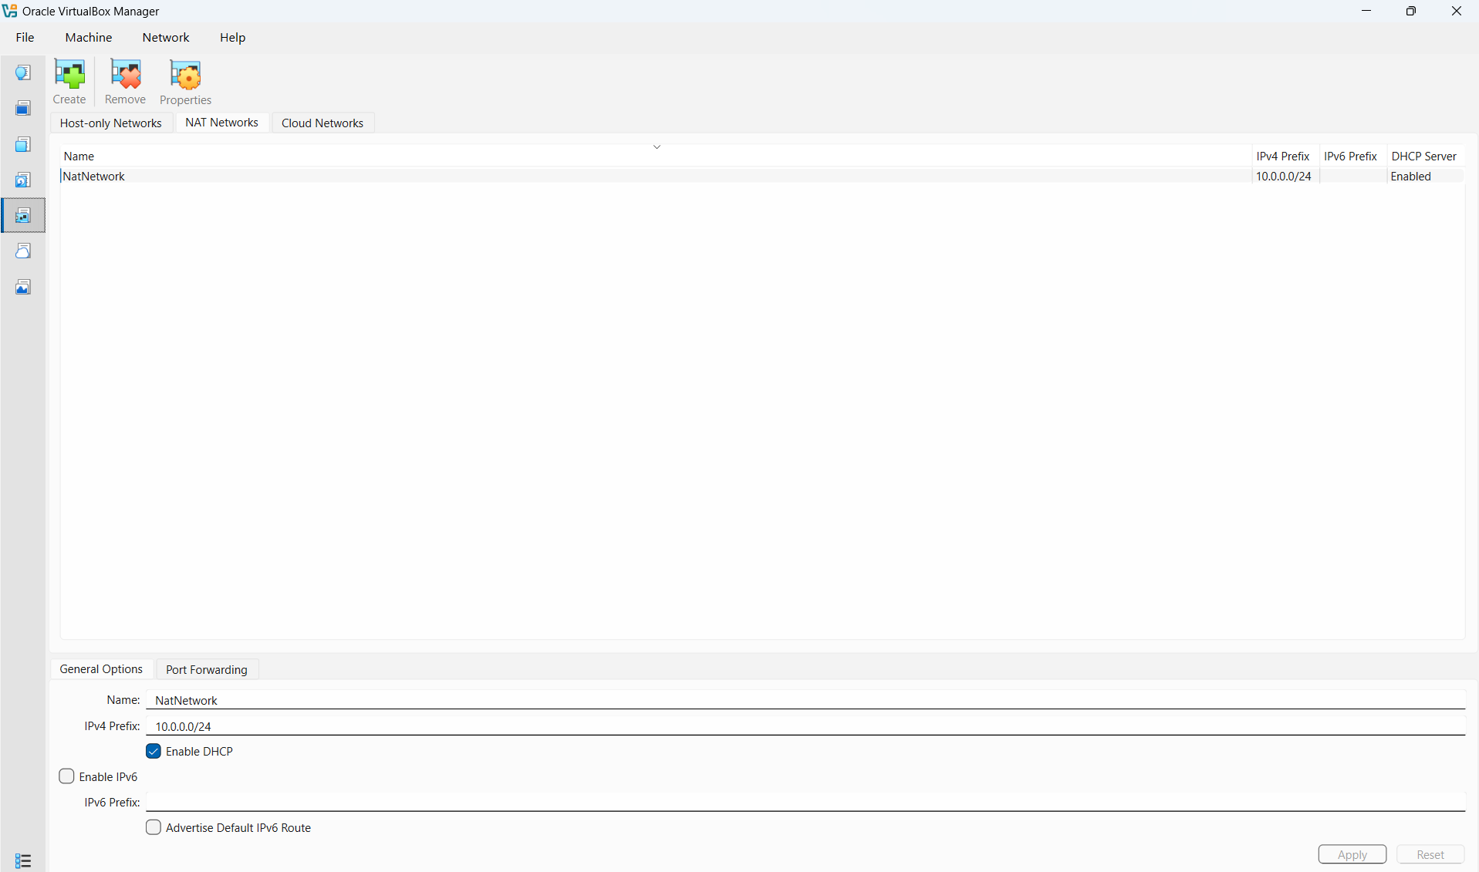
Step 4. Download & import Kali Linux Virtual Machine in your Virtualbox: https://kali.org/get-kali
I Have the IsO image of kali so I am using that
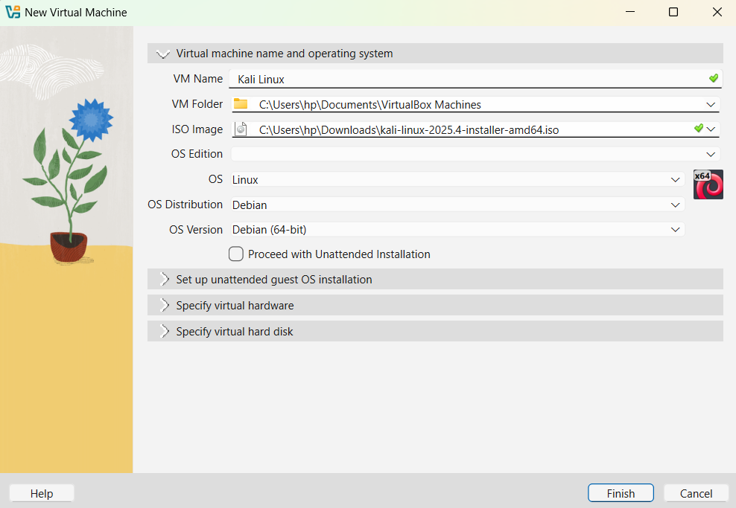
Memory = 6GB
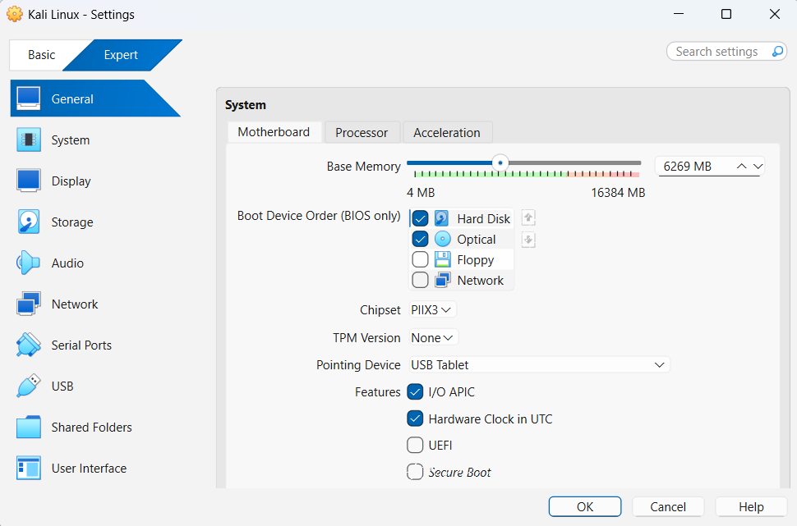
CpU cores = 2
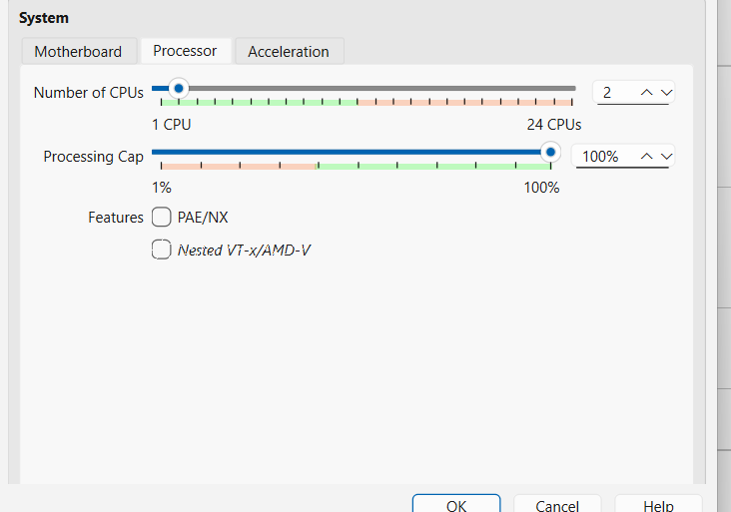
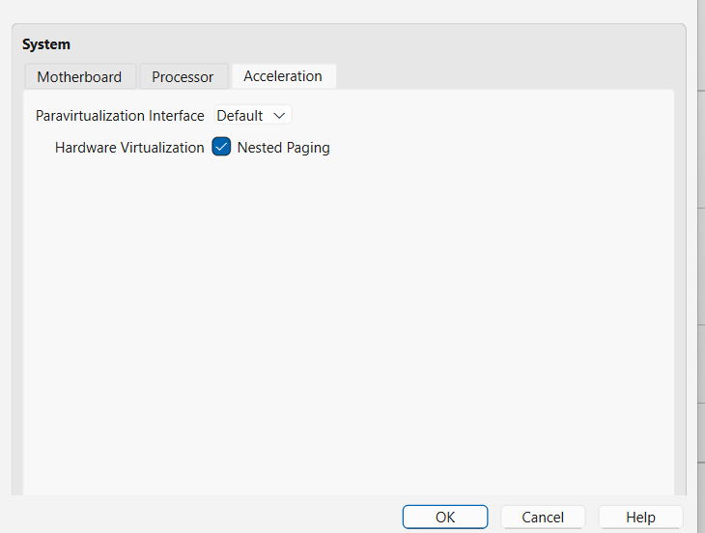
Network Setting = NAT Network
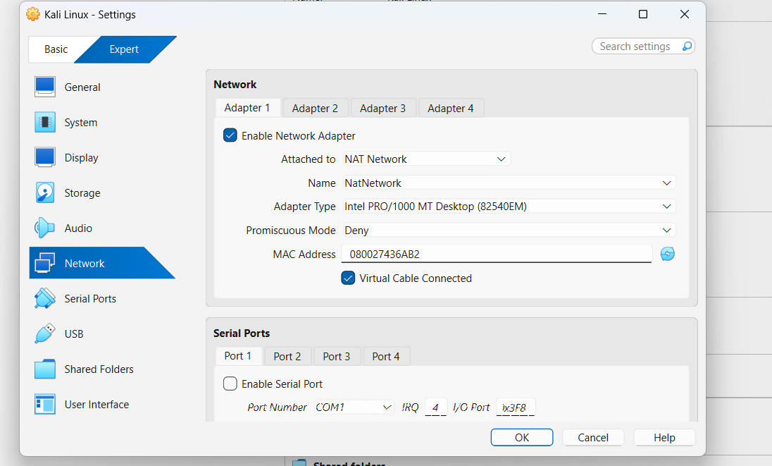
Start the Machine

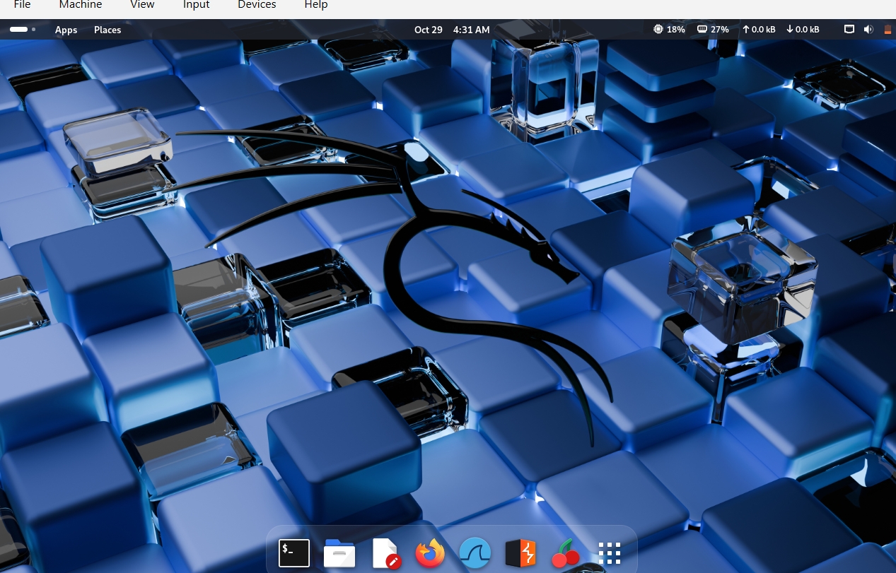

checking the nat networking

Step 5. Setup the IP configuration of Kali Linux
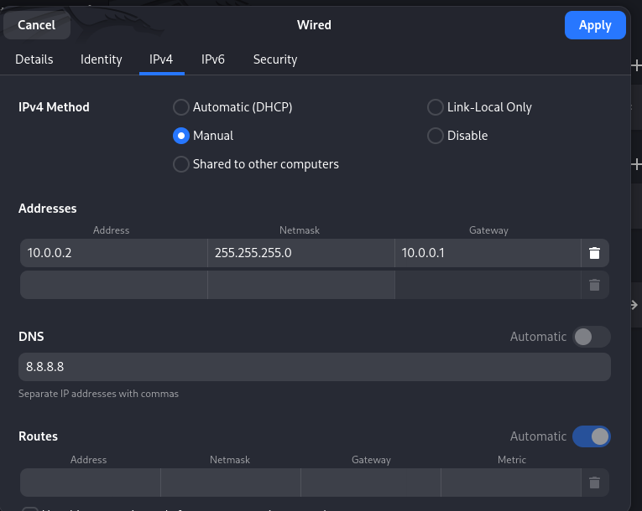
Checking connectivity
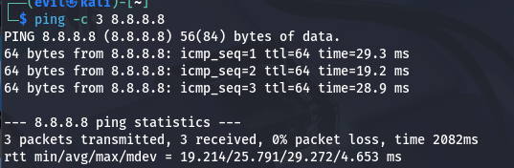
Checking by Opening firefox
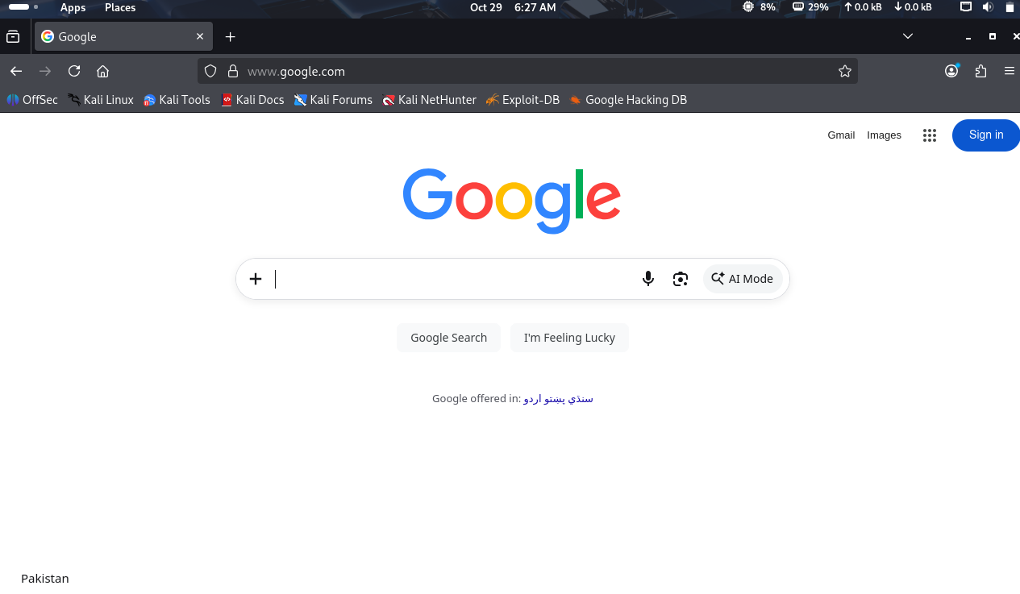

Step 06 :Clipboard Drag n Drop
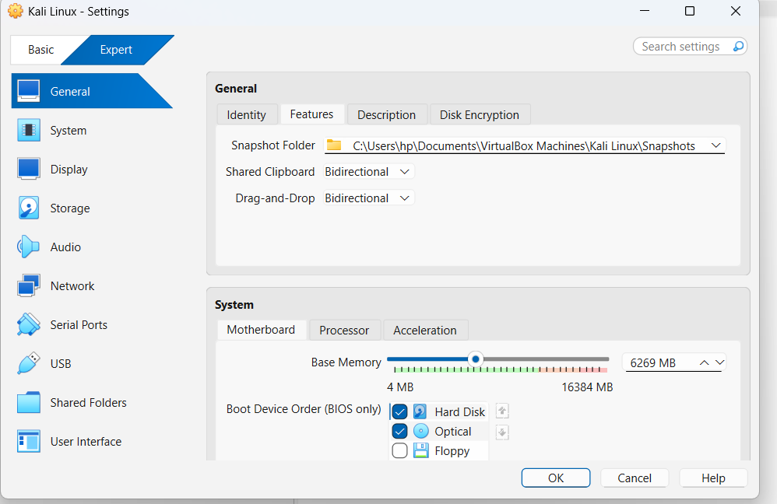
Step 07 Shared Folder
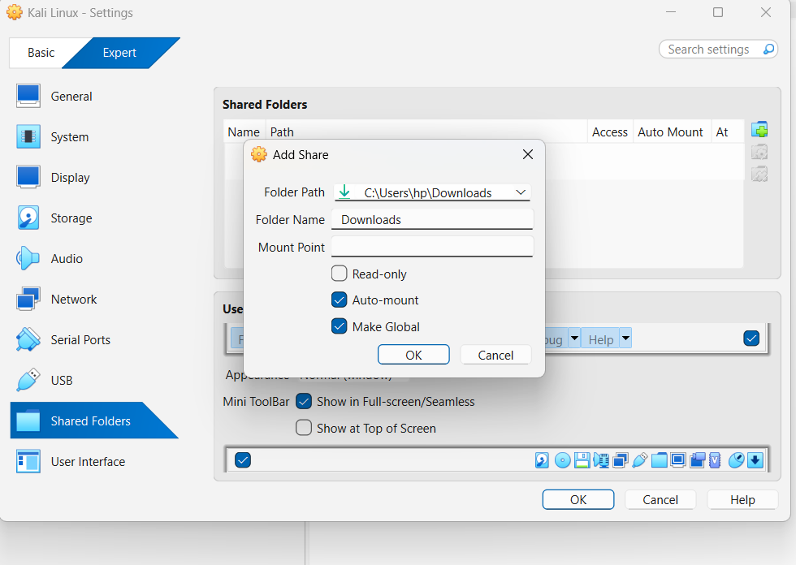
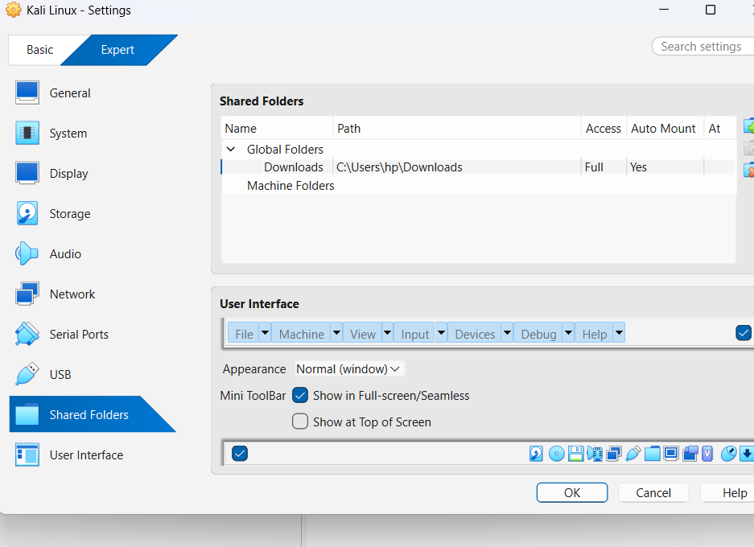

Step 8. Take snapshot of the VM
